POST WORK

0 FCFS
already uploaded fcfs with gantt chart in lab

1 SJF MODIFIED

#include<stdio.h>
#include<stdlib.h>
void swap(int *a,int *b)
{int temp;
temp=*a;
*a=*b;
*b=temp;
}
void main()
{int n,i,j,ct=0,null,oldct,smallb,foundb,index;
float sw=0,st=0;
printf("Enter the number of process : ");
scanf("%d",&n);
int *a=(int*)malloc(n*sizeof(int));
int *b=(int*)malloc(n*sizeof(int));
int *w=(int*)malloc(n*sizeof(int));
int *t=(int*)malloc(n*sizeof(int));
int *remb=(int*)malloc(n*sizeof(int));
for( i=0;i<n;++i)
{printf("Enter the AT of %d :",i+1);
scanf("%d",&a[i]);
printf("Enter the BT of %d :",i+1);
scanf("%d",&b[i]);
remb[i]=b[i];
w[i]=0;
}
for(i=0;i<n-1;++i)
for(j=i+1;j<n;++j)
{if(a[i]>a[j])
{swap(&b[i],&b[j]);
swap(&a[i],&a[j]);
}
else if(a[i]==a[j] && b[i] > b[j])
{
swap(&b[i],&b[j]);
swap(&a[i],&a[j]);
}
}
for(i=0;i<n;++i)
printf("P%d - AT :%d BT :%d \n",i+1,a[i],b[i]);
ct=a[0];
null=n;
do
{//null=0;
foundb=0;
for(i=0;a[i]<=ct;++i)
{
if(foundb==0 && remb[i]!=0)
{
smallb=b[i];
index=i;
foundb=1;
}
else if(remb[i]!=0 && smallb>b[i])
{
smallb=b[i];
index=i;
}
}

oldct=ct;
ct+=b[index];
remb[index]=0;
for(j=0;j<n;++j)
if(a[j]<=ct && index!=j && remb[j]!=0)
{
if(a[j]<=oldct)
w[j]+=b[index];
else
w[j]+=ct-a[j];
}
/*for(j=0;j<n;++j)
if(remb[j]!=0)
{
null=1;
break;
}
*/
null--;
}
while(null>0);

printf("Process \t Arrival Time \t Burst Time \t Waiting Time \t Turnaround Time\n");
for(i=0;i<n;++i)
{t[i]=w[i]+b[i];
printf("P%d \t \t %d \t \t %d \t \t %d \t \t %d \n",i+1,a[i],b[i],w[i],t[i]);
sw+=w[i];
st+=t[i];}
printf("Average waiting time is %f \nAverage turnaround time is %f \n",sw/n,st/n);
printf("GANT chart\n");
int *pid=(int*)malloc(n*sizeof(int));
int *finish=(int*)malloc(n*sizeof(int));
for(i=0;i<n;++i)
{
pid[i]=i;
finish[i]=a[i]+b[i]+w[i];
}
for(i=0;i<n-1;++i)
for(j=i+1;j<n;++j)
{if(finish[i]>finish[j])
{swap(&finish[i],&finish[j]);
swap(&pid[i],&pid[j]);
}
}
for(i=0;i<n;++i)
{printf("P%d \t",pid[i]+1);
}
printf("\n");
for(i=0;i<n;++i)
{printf("%d \t",finish[i]);
}
printf("\n");
}

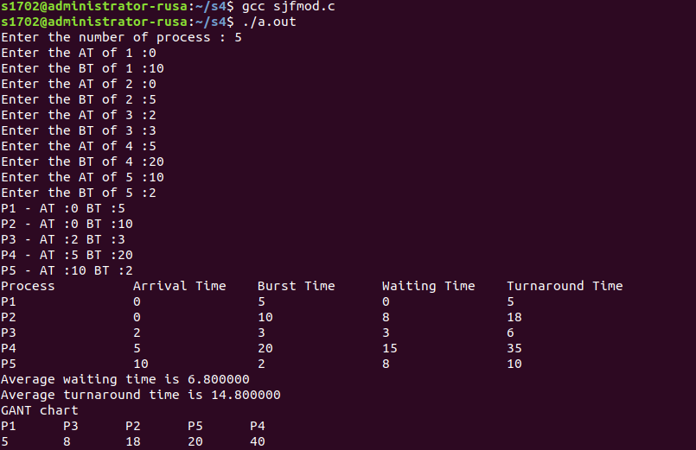

2 RR MODIFIED

GNU nano 2.9.3 RRmod.c

#include<stdio.h>
#include<stdlib.h>
#include<string.h>
void swap(int *a,int *b)
{int temp;
temp=*a;
*a=*b;
*b=temp;
}
void main()
{int n,i,j,tq,temp,null=0,ct;
float sw=0,st=0;
printf("Enter the number of process\n");
scanf("%d",&n);
printf("Enter time quantum\n");
scanf("%d",&tq);
int *remb=(int*)malloc(n*sizeof(int));
int *b=(int*)malloc(n*sizeof(int));
int *w=(int*)malloc(n*sizeof(int));
int *t=(int*)malloc(n*sizeof(int));
int *a=(int*)malloc(n*sizeof(int));
for( i=0;i<n;++i)
{printf("Enter the AT of %d :",i+1);
scanf("%d",&a[i]);
//printf("%d",a[i]);
printf("Enter the BT of %d :",i+1);
scanf("%d",&b[i]);
}
for(i=0;i<n-1;++i)
for(j=i+1;j<n;++j)
{if(a[i]>a[j])
{swap(&a[i],&a[j]);
swap(&b[i],&b[j]);
}
}

ct=a[0];
for(i=0;i<n;++i)
{
remb[i]=b[i];
}
int ghant[50],m=0,elem=0,ghantpos=0;
int time[50],point=0;
while(a[elem]<=ct)
{printf("###new process %d in GANT chart pos %d \n",elem+1,m+1);
ghant[m]=elem;
m++;
elem++;
}
i=0;
memset (w, 0, sizeof (int) * n);
do
//for(i=0;i<n;++i)
{//printf("*");
null=0;
if(remb[i]==0)
continue;
else if(remb[i] >= tq && a[i]<=ct)
{//printf("%d process bt >= tq",i+1);
remb[i]=remb[i]-tq;
temp=ct;
ct=ct+tq;
time[point++]=ct;
//printf("remaining time is %d past time is %d currenttime %d\n",remb[i],temp,ct);
for(j=0;j<n;++j)
{//printf("check for p%d with AT=%d RT=%d\n",j+1,a[j],remb[j]);
if(a[j]<=temp)
if(remb[j]!=0 && j!=i)
{//printf("P%d is waiting for %d\n",j+1,tq);
w[j]=w[j]+tq;
}
else
{//printf("own process\n");
}
else if(a[j] < ct && a[j] > temp)
{//printf("entered inbetween arrived\n");
if(remb[j]!=0 && j!=i)
{
w[j]=w[j]+ct-a[j];
//printf("P%d is waiting for %d\n",j+1,ct-a[j]);
}
else
{//do nothing
}
}
else
{//do nothing
}
}
while(elem<n && a[elem]<=ct)
{//printf("entered while loop to add new process\n");
ghant[m]=elem;
printf("###new process %d in GANT chart pos %d \n",elem+1,m+1);
elem++;
m++;
}
if(remb[i]!=0)
{ghant[m]=i;
printf("###old process %d again in GANT chart pos %d \n",i+1,m+1);
m++;}
}
else
{//printf("RT is less than tq \n ");
temp=remb[i];
remb[i]=0;
ct=ct+temp;
time[point++]=ct;
//printf("remaining time is %d current time is %d pasttime %d\n",remb[i],ct,ct-temp);
for(j=0;j<n;++j)
{if(a[j]<=(ct-temp))
if(remb[j]!=0 && j!=i)
{
w[j]=w[j]+temp;
}
else if(a[j]>(ct-temp) && a[j] < ct)
if(remb[j]!=0 && j!=i)
w[j]=w[j]+ct-a[j];
}
while(elem<n && a[elem]<=ct)
{printf("###new process %d in GANT chart pos %d \n",elem+1,m+1);
ghant[m]=elem;
elem++;
m++;
}
}
ghantpos++;
i=ghant[ghantpos];
//printf("next iteration is for P%d\n",i+1);
for(j=0;j<n;++j)
if(remb[j]!=0)
{
null=1;
break;
}
}
while(null);
for(i=0;i<n;++i)
{t[i]=w[i]+b[i];
}
printf("Process \t Burst Time \t Waiting Time \t Turnaround Time\n");
for(i=0;i<n;++i)
{printf("P%d \t \t %d \t \t %d \t \t %d \n",i+1,b[i],w[i],t[i]);
sw+=w[i];
st+=t[i];}
printf("Average waiting time is %f \nAverage turnaround time is %f \n",sw/n,st/n);
printf("GANTT CHART\n\n");
for(i=0;i<point;++i)
printf("P%d ",ghant[i]+1);
printf("\n");
for(i=0;i<point;++i)
printf("%d ",time[i]);
printf("\n");
}

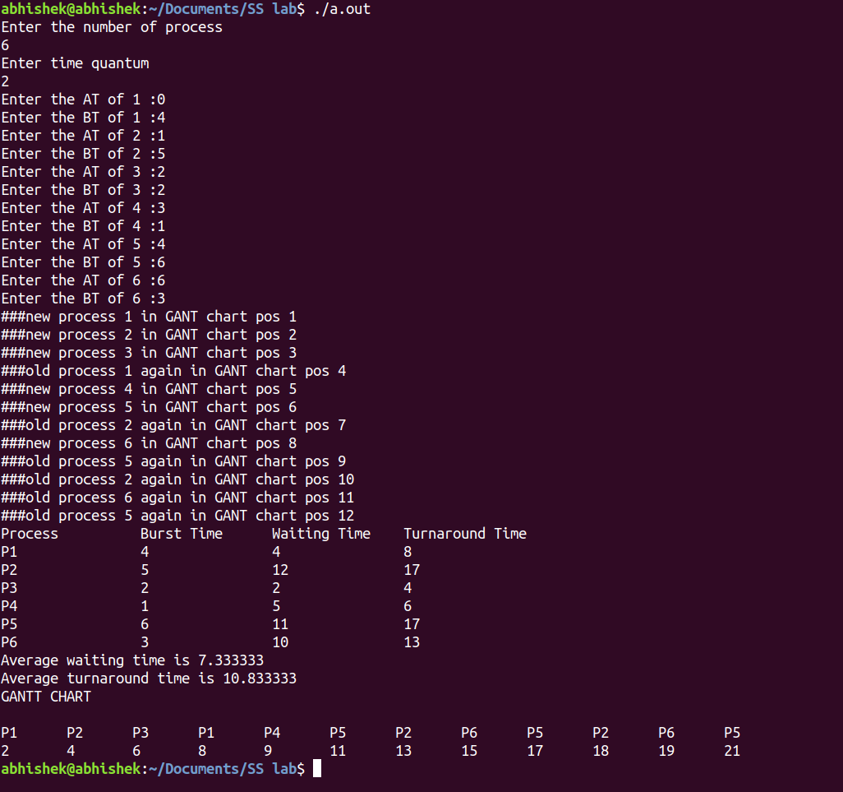

3 PRIORITY MODIFIED

#include<stdlib.h>
#include<stdio.h>
void swap(int *a,int *b)
{int temp;
temp=*a;
*a=*b;
*b=temp;
}
void main()
{int n,i,j,ct=0,null,oldct,smallb,foundb,index;
float sw=0,st=0;
printf("Enter the number of process : ");
scanf("%d",&n);
int *a=(int*)malloc(n*sizeof(int));
int *b=(int*)malloc(n*sizeof(int));
int *w=(int*)malloc(n*sizeof(int));
int *t=(int*)malloc(n*sizeof(int));
int *remb=(int*)malloc(n*sizeof(int));
int *prio=(int*)malloc(n*sizeof(int));
for( i=0;i<n;++i)
{
printf("Enter the AT of %d :",i+1);
scanf("%d",&a[i]);
printf("Enter the BT of %d :",i+1);
scanf("%d",&b[i]);
printf("Enter the Priority of %d :",i+1);
scanf("%d",&prio[i]);
remb[i]=b[i];
w[i]=0;
}
for(i=0;i<n-1;++i)
for(j=i+1;j<n;++j)
{if(a[i]>a[j])
{swap(&b[i],&b[j]);
swap(&a[i],&a[j]);
swap(&prio[i],&prio[j]);
}
else if(a[i]==a[j] && prio[i] > prio[j])
{
swap(&b[i],&b[j]);
swap(&a[i],&a[j]);
swap(&prio[i],&prio[j]);
}
}
for(i=0;i<n;++i)
printf("P%d - AT :%d BT :%d Prio :%d \n",i+1,a[i],b[i],prio[i]);
ct=a[0];
null=n;
do
{//null=0;
foundb=0;
for(i=0;a[i]<=ct;++i)
{
if(foundb==0 && remb[i]!=0)
{
smallb=prio[i];
index=i;
foundb=1;
}
else if(remb[i]!=0 && smallb>prio[i])
{
smallb=prio[i];
index=i;
}
}

oldct=ct;
ct+=b[index];
remb[index]=0;
for(j=0;j<n;++j)
if(a[j]<=ct && index!=j && remb[j]!=0)
{
if(a[j]<=oldct)
w[j]+=b[index];
else
w[j]+=ct-a[j];
}
/*for(j=0;j<n;++j)
if(remb[j]!=0)
{
null=1;
break;
}
*/
null--;
}
while(null>0);

printf("Process \t Arrival Time \t Burst Time \t Priority \t Waiting Time \t Turnaround Time\n");
for(i=0;i<n;++i)
{t[i]=w[i]+b[i];
printf("P%d \t \t %d \t \t %d \t \t %d \t \t %d \t \t %d \n",i+1,a[i],b[i],prio[i],w[i],t[i]);
sw+=w[i];
st+=t[i];}
printf("Average waiting time is %f \nAverage turnaround time is %f \n",sw/n,st/n);
printf("GANT chart\n");
int *pid=(int*)malloc(n*sizeof(int));
int *finish=(int*)malloc(n*sizeof(int));
for(i=0;i<n;++i)
{
pid[i]=i;
finish[i]=a[i]+b[i]+w[i];
}
for(i=0;i<n-1;++i)
for(j=i+1;j<n;++j)
{if(finish[i]>finish[j])
{swap(&finish[i],&finish[j]);
swap(&pid[i],&pid[j]);
}
}
for(i=0;i<n;++i)
{printf("P%d \t",pid[i]+1);
}
printf("\n");
for(i=0;i<n;++i)
{printf("%d \t",finish[i]);
}
printf("\n");
}

